**Scenario**: You are given the task to test out a new area of the investment website that gives the user breakdown of category of his total investment. You are given both an image of the design and acceptance criteria / requirements. Please review them below:

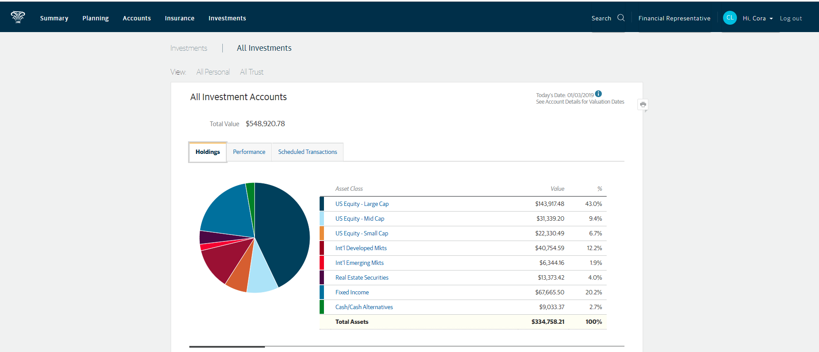

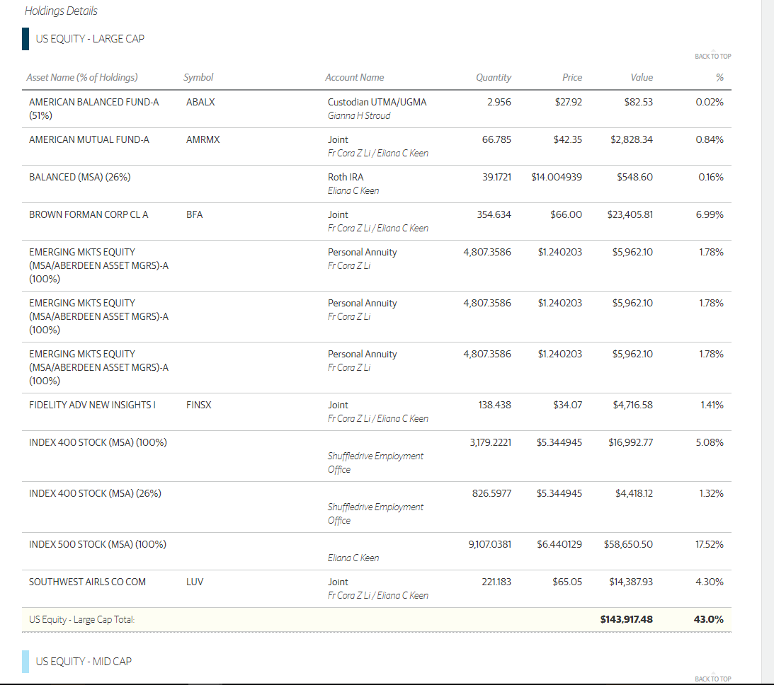

**Acceptance Criteria / Requirements:**

When user logs into he/she should be able to see how their investments assets are classified. User should be able to drill down on each of the asset classes and where asset name , value break down is given and % is calculated.

**Task 1** : Write a list of questions or uncertainties you may have that you would ask a designer or stakeholder concerning the image or acceptance criteria/requirements.

**Task 2** : Write a list of data or users in a certain state that you may need to properly test this.

**Task 3** : Write a list of high-level test scenarios that you can think of based only on the design and acceptance criteria you are given. After you list them out, number them in terms of priority (1 - must test, 2 - should test, 3 - test only if there is time).

**Task 4:** Imagine that you find a defect while testing the above. Write a sample defect report below:

**Task 5:** What scenarios would you consider valid for automation? Why?